LAB PROGRAM
CHAPTER 3
1. Write a Program to find both the maximum and minimum values in the array. Implement using any
programming language of your choice. Execute your code and provide the maximum and
minimum values found.
CODE
arr = [5, 7, 3, 4, 9, 12, 6, 2]
maximum = arr[0]
minimum = arr[0]
for i in arr:
if i > maximum:
maximum = i
if i < minimum:
minimum = i
print("Min =", minimum)
print("Max =", maximum)
OUTPUT
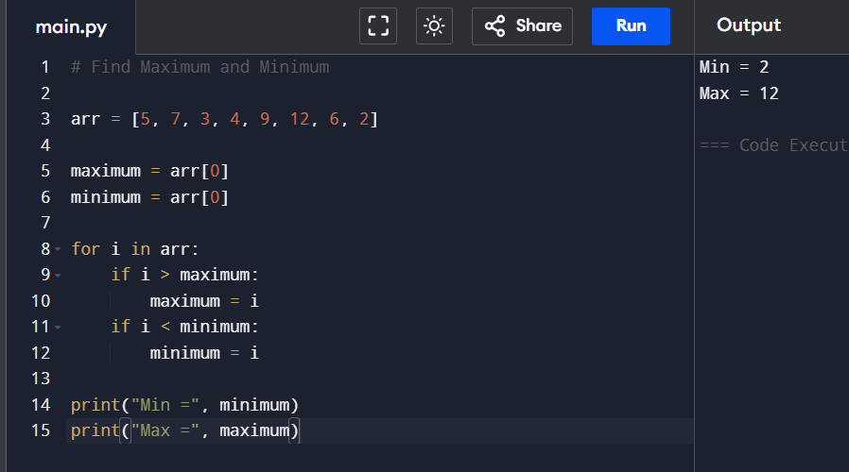
2. Consider an array of integers sorted in ascending order: 2,4,6,8,10,12,14,18. Write a Program to
find both the maximum and minimum values in the array. Implement using any programming
language of your choice. Execute your code and provide the maximum and minimum values found.
CODE
arr = [2, 4, 6, 8, 10, 12, 14, 18]
minimum = arr[0]
maximum = arr[-1]
print("Min =", minimum)
print("Max =", maximum)
OUTPUT
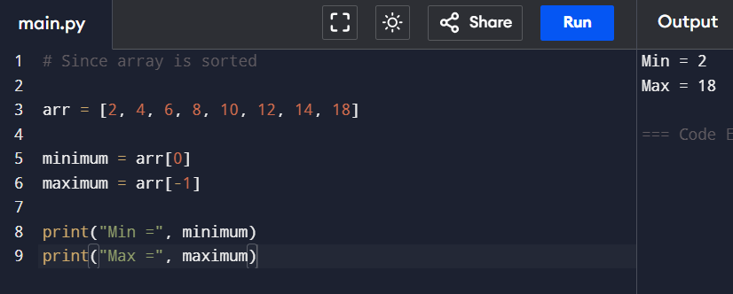
3. You are given an unsorted array 31,23,35,27,11,21,15,28. Write a program for Merge Sort and
implement using any programming language of your choice.
CODE
def merge_sort(arr):
if len(arr) > 1:
mid = len(arr) // 2
left = arr[:mid]
right = arr[mid:]

merge_sort(left)
merge_sort(right)
i = j = k = 0
while i < len(left) and j < len(right):
if left[i] < right[j]:
arr[k] = left[i]
i += 1
else:
arr[k] = right[j]
j += 1
k += 1
while i < len(left):
arr[k] = left[i]
i += 1
k += 1
while j < len(right):
arr[k] = right[j]
j += 1
k += 1
arr = [31,23,35,27,11,21,15,28]
merge_sort(arr)
print("Sorted Array:")
print(arr)

OUTPUT
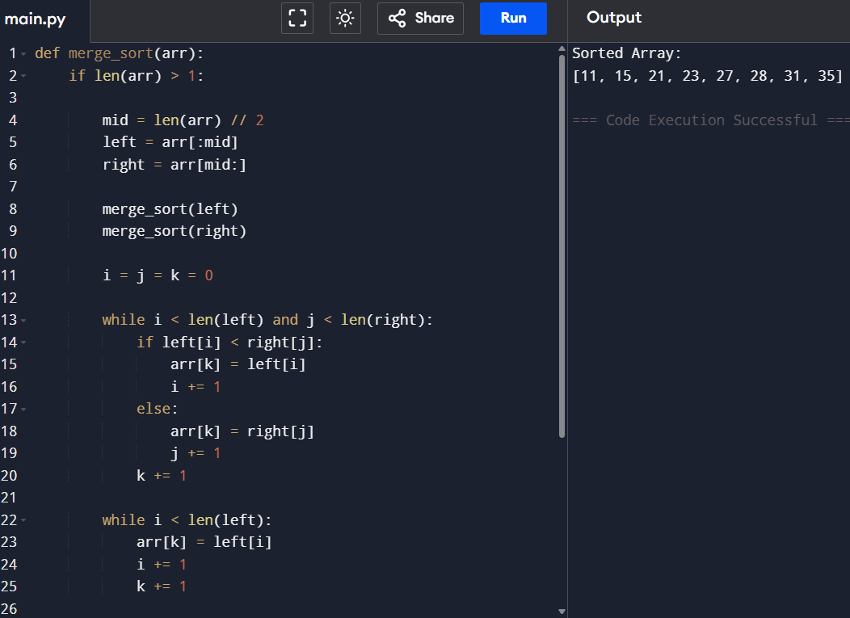
4. Implement the Merge Sort algorithm in a programming language of your choice and test it on the
array 12,4,78,23,45,67,89,1. Modify your implementation to count the number of comparisons
made during the sorting process. Print this count along with the sorted array.
CODE
count = 0
def merge_sort(arr):
global count
if len(arr) > 1:
mid = len(arr)//2
left = arr[:mid]
right = arr[mid:]
merge_sort(left)
merge_sort(right)

i = j = k = 0
while i < len(left) and j < len(right):
count += 1
if left[i] < right[j]:
arr[k] = left[i]
i += 1
else:
arr[k] = right[j]
j += 1
k += 1
while i < len(left):
arr[k] = left[i]
i += 1
k += 1
while j < len(right):
arr[k] = right[j]
j += 1
k += 1
arr = [12,4,78,23,45,67,89,1]
merge_sort(arr)
print("Sorted Array:", arr)
print("Comparisons:", count)

OUTPUT
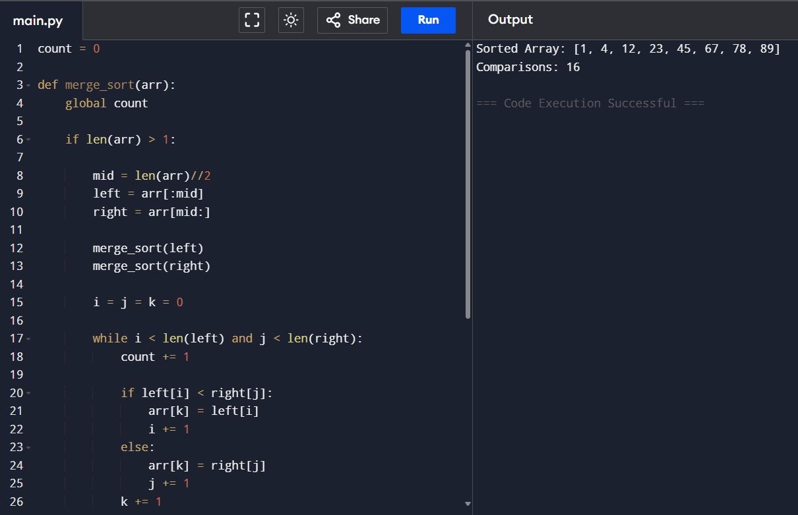
5. Given an unsorted array 10,16,8,12,15,6,3,9,5 Write a program to perform Quick Sort. Choose the
first element as the pivot and partition the array accordingly. Show the array after this partition.

Recursively apply Quick Sort on the sub-arrays formed. Display the array after each recursive call
until the entire array is sorted.
CODE
def partition(arr, low, high):
pivot = arr[low]
i = low + 1
j = high
while True:
while i <= j and arr[i] <= pivot:
i += 1
while i <= j and arr[j] > pivot:
j -= 1
if i <= j:
arr[i], arr[j] = arr[j], arr[i]
else:
break
arr[low], arr[j] = arr[j], arr[low]
return j
def quick_sort(arr, low, high):
if low < high:
p = partition(arr, low, high)
print("After Partition:", arr)
quick_sort(arr, low, p - 1)
quick_sort(arr, p + 1, high)
arr = [10,16,8,12,15,6,3,9,5]
print("Original Array:", arr)
quick_sort(arr, 0, len(arr)-1)
print("Sorted Array:", arr)
OUTPUT
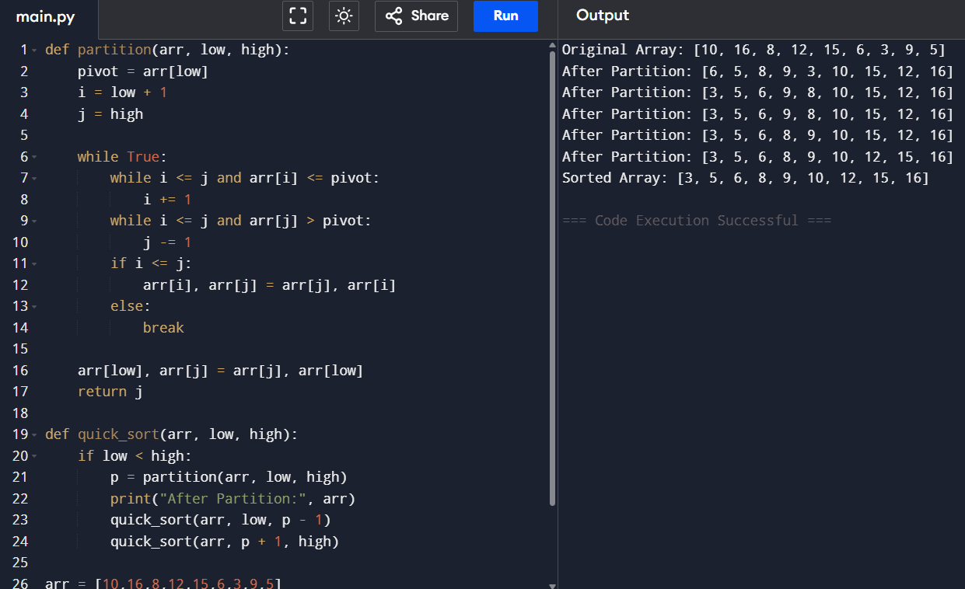

6. Implement the Quick Sort algorithm in a programming language of your choice and test it on the
array 19,72,35,46,58,91,22,31. Choose the middle element as the pivot and partition the array
accordingly. Show the array after this partition. Recursively apply Quick Sort on the sub-arrays
formed. Display the array after each recursive call until the entire array is sorted. Execute your code
and show the sorted array.
CODE
def quick_sort(arr):
if len(arr) <= 1:
return arr
pivot = arr[len(arr)//2]
left = [x for x in arr if x < pivot]
middle = [x for x in arr if x == pivot]
right = [x for x in arr if x > pivot]
result = quick_sort(left) + middle + quick_sort(right)
print(result)
return result
arr = [19,72,35,46,58,91,22,31]
print("Original:", arr)
sorted_arr = quick_sort(arr)
print("Sorted:", sorted_arr)
OUTPUT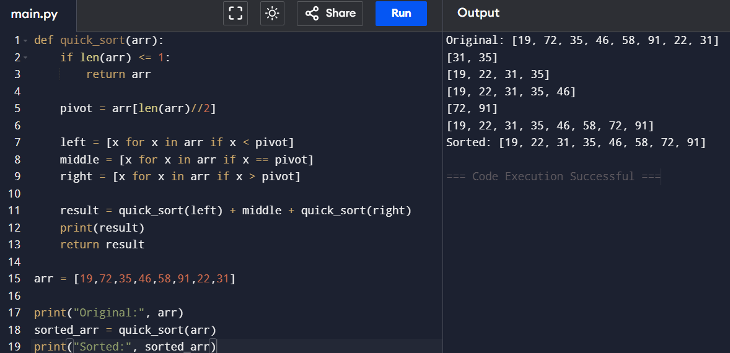
7. Implement the Binary Search algorithm in a programming language of your choice and test it on the
array 5,10,15,20,25,30,35,40,45 to find the position of the element 20. Execute your code and
provide the index of the element 20. Modify your implementation to count the number of
comparisons made during the search process. Print this count along with the result.
CODE
def binary_search(arr, key):
low = 0
high = len(arr)-1
comparisons = 0
while low <= high:
comparisons += 1
mid = (low + high)//2
if arr[mid] == key:
return mid + 1, comparisons
elif arr[mid] < key:
low = mid + 1
else:
high = mid - 1
return -1, comparisons
arr = [5,10,15,20,25,30,35,40,45]
key = 20
pos, count = binary_search(arr,key)
print("Position:", pos)
print("Comparisons:", count)

OUTPUT
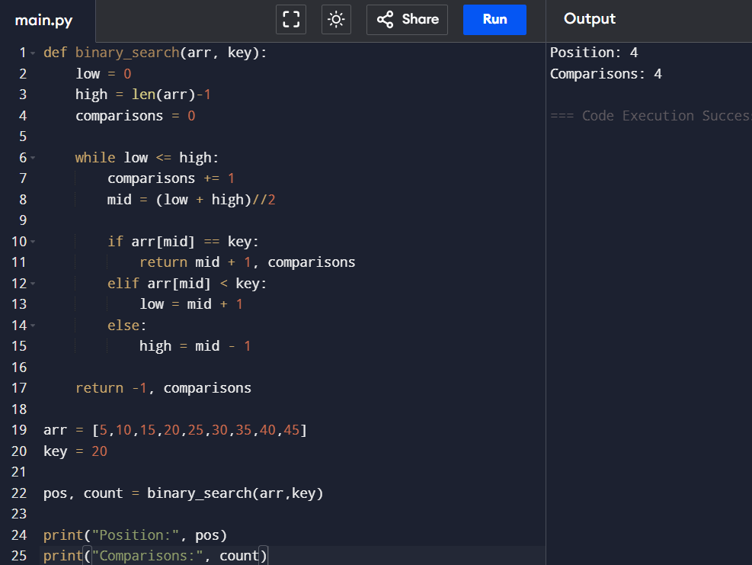
8. You are given a sorted array 3,9,14,19,25,31,42,47,53 and asked to find the position of the element
31 using Binary Search. Show the mid-point calculations and the steps involved in finding the
element. Display, what would happen if the array was not sorted, how would this impact the
performance and correctness of the Binary Search algorithm?
CODE
def binary_search_steps(arr,key):
low = 0
high = len(arr)-1
while low <= high:
mid = (low+high)//2
print("Low =",low,
"High =",high,
"Mid =",mid,
"Value =",arr[mid])
if arr[mid]==key:
print("Found at Position:",mid+1)
return
elif arr[mid]<key:
low=mid+1
else:
high=mid-1
print("Not Found")
arr=[3,9,14,19,25,31,42,47,53
binary_search_steps(arr,31)
print("\nBinary Search requires sorted array.")
OUTPUT
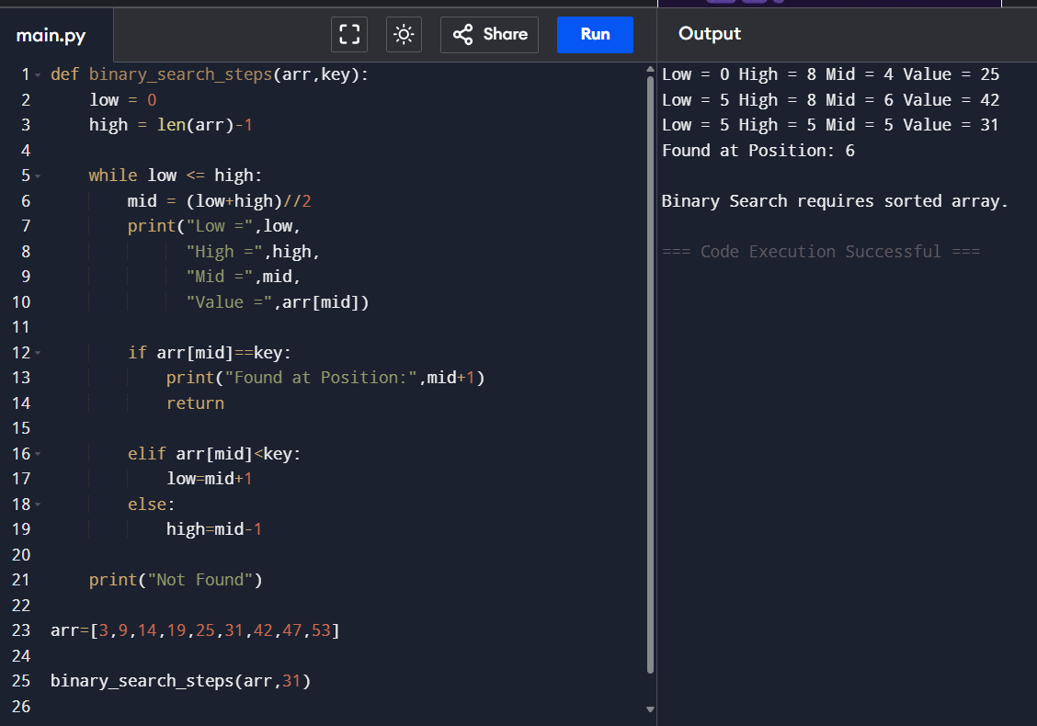

9. Given an array of points where points[i] = [xi, yi] represents a point on the X-Y plane and
an integer k, return the k closest points to the origin (0, 0).
CODE
import heapq
def kClosest(points,k):
return heapq.nsmallest(
k,
points,
key=lambda p:p[0]**2+p[1]**2
)
points=[[1,3],[-2,2],[5,8],[0,1]]
k=2
print(kClosest(points,k))
OUTPUT
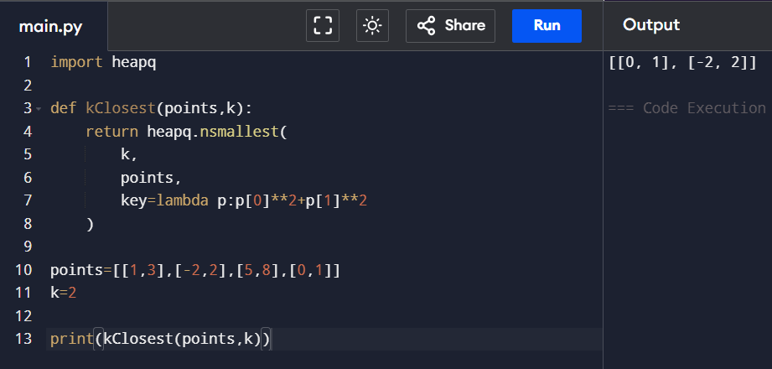
10. Given four lists A, B, C, D of integer values,Write a program to compute how many tuples
n(i, j, k, l) there are such that A[i] + B[j] + C[k] + D[l] is zero.
CODE
from collections import defaultdict

def fourSumCount(A,B,C,D):
m=defaultdict(int)
for a in A:
for b in B:
m[a+b]+=1
count=0
for c in C:
for d in D:
count+=m[-(c+d)]
return count
A=[1,2]
B=[-2,-1]
C=[-1,2]
D=[0,2]
print(fourSumCount(A,B,C,D))

OUTPUT
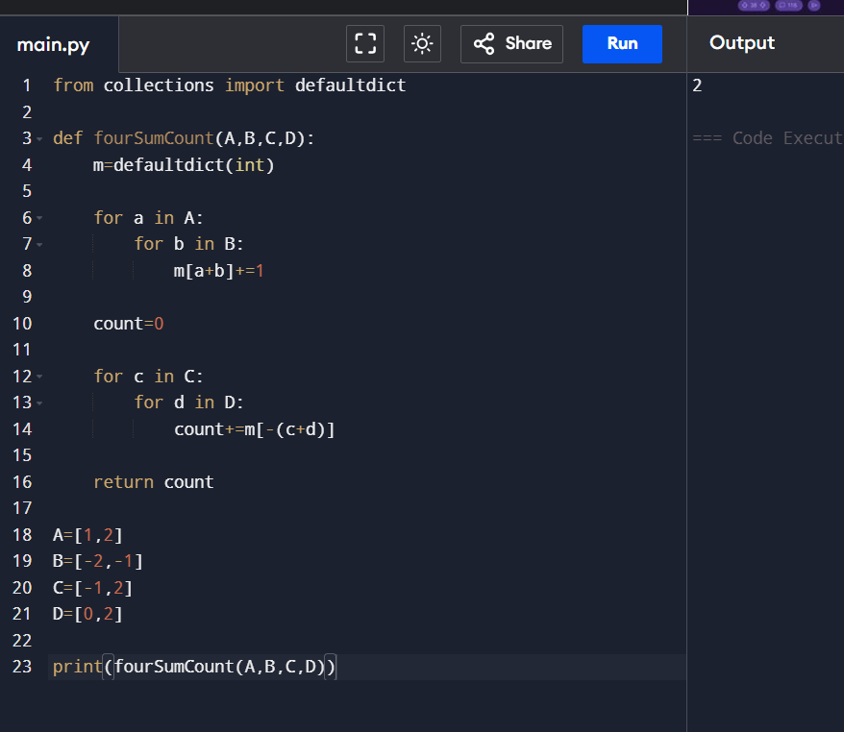
11. To Implement the Median of Medians algorithm ensures that you handle the worst-case
time complexity efficiently while finding the k-th smallest element in an unsorted array.
CODE
def median_of_medians(arr,k):
if len(arr)<=5:
return sorted(arr)[k-1]
groups=[arr[i:i+5] for i in range(0,len(arr),5)]
medians=[sorted(g)[len(g)//2] for g in groups]
pivot=median_of_medians(medians,(len(medians)+1)//2)
lows=[x for x in arr if x<pivot]
highs=[x for x in arr if x>pivot]
pivots=[x for x in arr if x==pivot]
if k<=len(lows):
return median_of_medians(lows,k)
elif k<=len(lows)+len(pivots):
return pivot
else:
return median_of_medians(
highs,
k-len(lows)-len(pivots)
)

arr=[12,3,5,7,19]
k=2
print(median_of_medians(arr,k))

OUTPUT
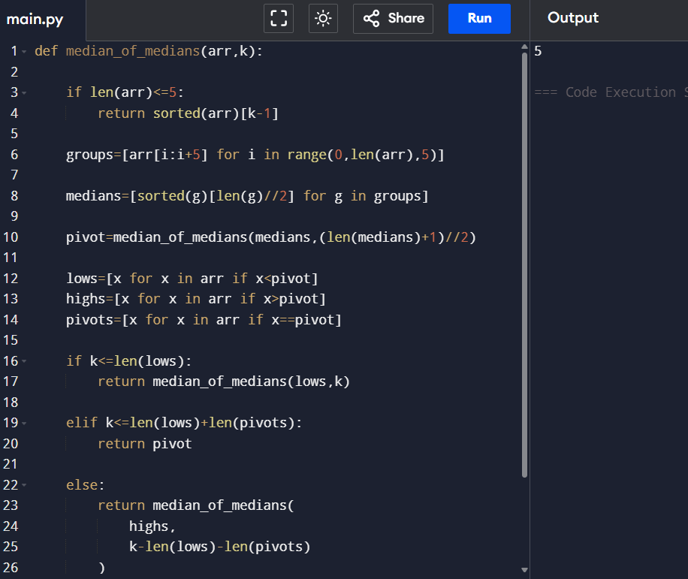
12. To Implement a function median_of_medians(arr, k) that takes an unsorted
CODE
def median_of_medians(arr,k):
if len(arr)<=5:
return sorted(arr)[k-1]
groups=[arr[i:i+5] for i in range(0,len(arr),5)]
medians=[sorted(g)[len(g)//2] for g in groups]
pivot=median_of_medians(medians,(len(medians)+1)//2)
left=[x for x in arr if x<pivot]
equal=[x for x in arr if x==pivot]
right=[x for x in arr if x>pivot]

if k<=len(left):
return median_of_medians(left,k)
elif k<=len(left)+len(equal):
return pivot

return median_of_medians(
right,
k-len(left)-len(equal)
)
arr=[23,17,31,44,55,21,20,18,19,27]

print(median_of_medians(arr,5))
OUTPUT
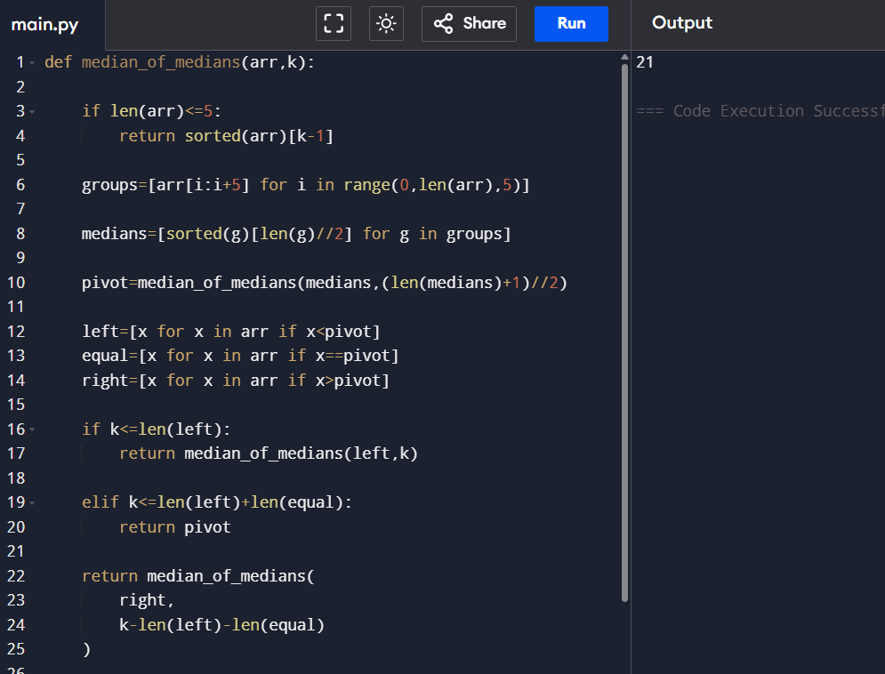
13. Write a program to implement Meet in the Middle Technique. Given an array of integers
and a target sum, find the subset whose sum is closest to the target. You will use the Meet
in the Middle technique to efficiently find this subset.
CODE
from itertools import combinations
def subset_sums(nums):
sums=[]
n=len(nums)
for r in range(n+1):
for comb in combinations(nums,r):
sums.append(sum(comb))
return sums
def closest_subset(arr,target):
mid=len(arr)//2

left=subset_sums(arr[:mid])
right=subset_sums(arr[mid:])

best=None
for l in left:
for r in right:
total=l+r

if best is None or abs(target-total)<abs(target-best):
best=total
return best
arr=[45,34,4,12,5,2]

print(closest_subset(arr,42))

OUTPUT
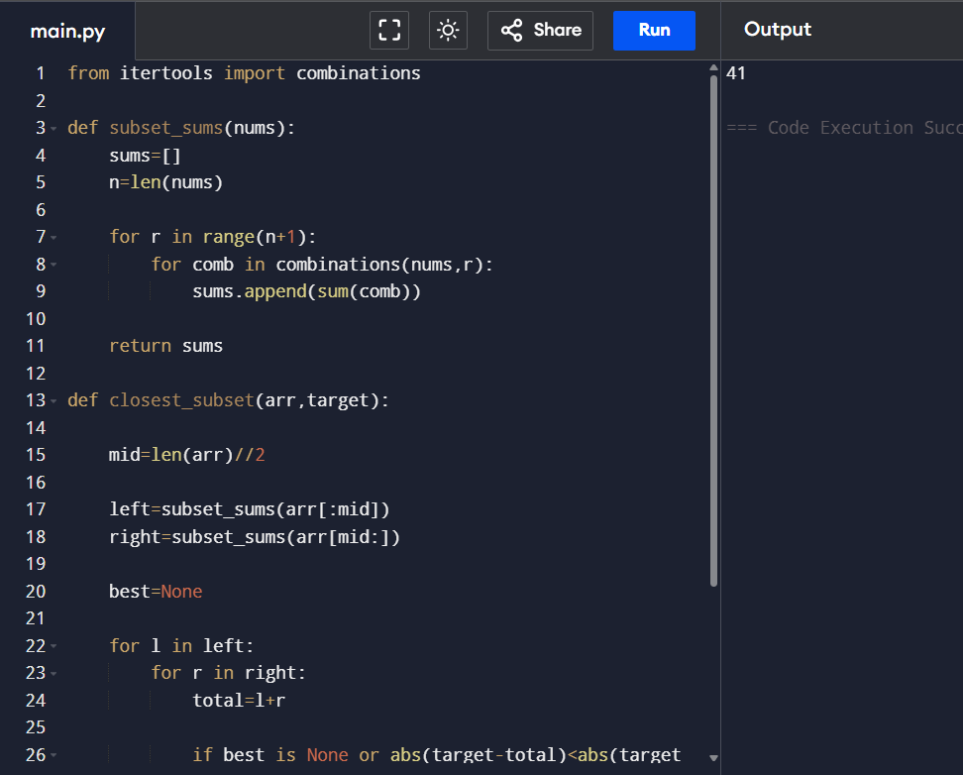
14. Write a program to implement Meet in the Middle Technique. Given a large array of
integers and an exact sum E, determine if there is any subset that sums exactly to E. Utilize
the Meet in the Middle technique to handle the potentially large size of the array. Return
true if there is a subset that sums exactly to E, otherwise return false.
CODE
from itertools import combinations
def subset_sums(nums):
sums=[]
n=len(nums)
for r in range(n+1):
for comb in combinations(nums,r):
sums.append(sum(comb))
return sums
def exact_subset(arr,target):
mid=len(arr)//2
left=subset_sums(arr[:mid])
right=set(subset_sums(arr[mid:]))

for x in left:
if target-x in right:
return True

return False

arr=[1,3,9,2,7,12]
print(exact_subset(arr,15))
OUTPUT
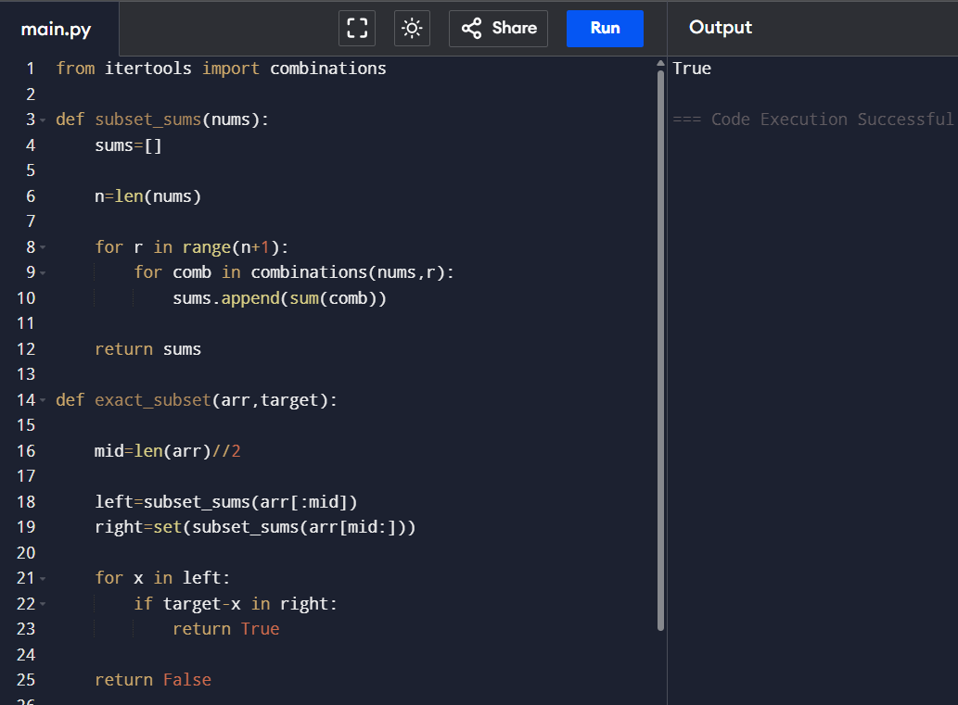

15 Given two 2×2 Matrices A and B
A=(1 7​ B=( 1 3
3 5​) 7 5)
Use Strassen&#39;s matrix multiplication algorithm to compute the product matrix C such that
C=A×B.
CODE
def strassen(A,B):

a,b=A[0]
c,d=A[1]

e,f=B[0]
g,h=B[1]

p1=a*(f-h)
p2=(a+b)*h
p3=(c+d)*e
p4=d*(g-e)
p5=(a+d)*(e+h)
p6=(b-d)*(g+h)
p7=(a-c)*(e+f)
c11=p5+p4-p2+p6
c12=p1+p2
c21=p3+p4
c22=p1+p5-p3-p7
return [[c11,c12],[c21,c22]]
A=[[1,7],
[3,5]]

B=[[1,3],
[7,5]]
C=strassen(A,B)
for row in C:
print(row)
OUTPUT
